Thermistor Lab Report

Thermistor Lab

by

Andrew Struthers

This lab was to demonstrate the proper use of an NI Data Acquisition Device (DAQ) and a thermistor to gather accurate temperature data, with a much more precise measuring device.

Introduction

The main point of this experiment is to gather temperature data from a thermistor and a programmable voltage source using an NI Data Acquisition Device (DAQ). The lab involves using a NI-9205 module for the DAQ, and a thermistor temperature sensor rated for 10K ohms @ 25 degrees Celsius. The software used is NI software version 18.0 for the coding and other software. This experiment involves measuring temperature using a thermistor. The process will include acquiring voltage readings from the thermistor, using a formula to convert measured resistance to temperature, then displaying to a graph. The theory is that a thermistor will have a much more accurate temperature reading than the thermocouple, and the thermistor will quickly respond to an increase in heat after being put under a heat gun.

Software

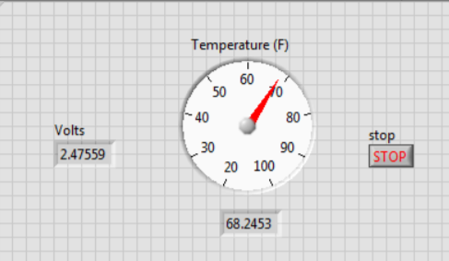To start this lab, a VI with a front panel shown in Figure 1 was to be constructed. Initially, the double display Voltage field was a numeric user input control, and the gauge was wired directly to the user input. There was also no formula attached to the user input, as familiarity with the gauge was just beginning to be established. Eventually, a formula was added in to the logic control, which established a relationship between voltages and output temperatures. The formula is shown in Figure 2.

Figure 1 - Front End for VI

The formula was derived by modifying the original equation $R={R_{R}}^{B\left(\frac{1}{T}-\frac{1}{T_{R}}\right)}$ into a form where we actually get temperature as an output. This modified form was $T={\left(\frac{1}{T_{R}}+\frac{1}{B}*\ln\left(\frac{R_{l}V}{R_{R}\left(V_{i}-V\right)}\right)\right)}^{-1}$. This way, the equation yields temperature as a function of resistance and voltage. The values for all these terms is known, except for V, which is the measured voltage.

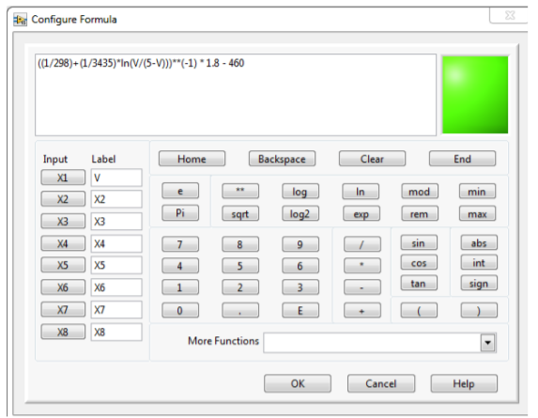

Figure 2 - Formula for Temperature as a Function of Voltage

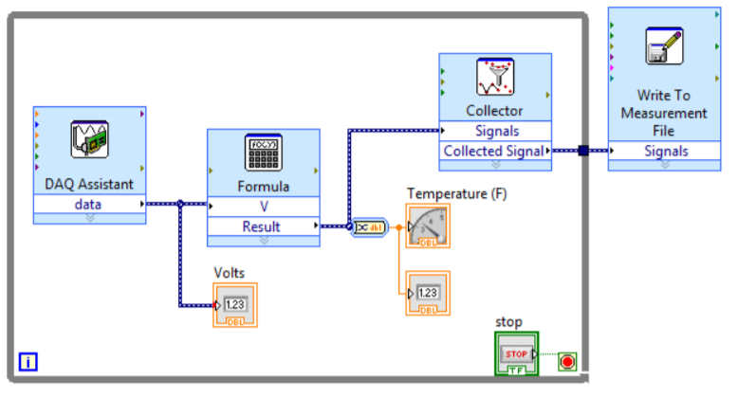The second half of the software of this lab involved wiring the block diagram of the VI to do what was needed. The code for this VI is shown in Figure 3. First, the DAQ assistant needed to be set up to look for voltages in the range 0V – 5V, at a rate of 10 Hz and a sample collection of 10 data points. This way, only 10 data points will be collected every second, to keep the number of data points manageable. The output from the DAQ assistant is then routed through a Formula VI that contains the formula found in Figure 2. This output is then displayed on the gauge and in a double output control. In addition, the temperature is also sent to a collector. The collector guarantees that the Write to File block won’t just write the last piece of data it gets, it will write the collection of data throughout the whole program. There is a Boolean stop button wired to the exit condition of the loop so that the program can stop safely whenever it is required to stop.

Hardware

With this code complete, the software side of the lab is done, and the hardware section can be finished. The hardware involved in this lab was a 10K ohm resistor, a thermistor rated for 10K ohms at 10 degrees C, a PWS4305 programmable power supply, and a heat gun. The wiring is shown in Figure 4.

Figure 3 - NI Code for the Thermistor VI

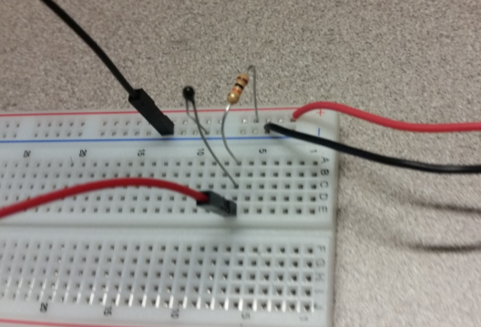Results

The module started collecting data from the thermistor, and the resulting converted temperatures were displayed on the gauge and the numeric displays. The room is roughly 74 degrees during the day. The heat gun brought the thermistor up to about 150 degrees. The thermistor was much quicker to respond than the thermocouple, and it was much more accurate. A visualization of the data is included in the ThermistorLabGraph.xlsx, but a quick snippet is available in Figure 5.

Figure 4 - Wiring Setup with 10K Ohm Resistor and Thermistor

A close up of text on a white background

Description generated with high confidenceTroubleshooting

The wiring took a bit to figure out, and there were some unexpected results initially. The VI was not displaying the correct temperature, and after some troubleshooting, the power wire was found to not have any electrical contact with the power supply, as it was inserted much too far for the contacts to catch. Then, the ground wire was not placed in the right terminal of the DAQ device, which took a little longer to realize. After both those problems were solved, the VI worked as expected and nothing else went haywire.

Figure - Visualization of Data

References

The references were as follows:

* Thermistor Lab Description - https://canvas.cwu.edu/courses/56610/files/5540180/download?wrap=1